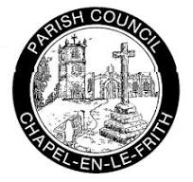
Chapel-en-le-Frith Parish Council and Community Newsletter Issue 2: March 2024

Parish Council News
Legal matters, and your Council Tax
Many residents will be aware that the Parish Council has been the defendant in litigation re perceived nuisance caused to two nearby households by public activity in the Memorial Park (which the Council owns). Court hearings re this will be ongoing for quite some weeks yet, with out of court negotiations also happening behind the scenes between ourselves and the complainants.

Residents often ask us for updates on those negotiations, but legal restrictions mean we won't be able to comment until they are concluded. We do recognise that, as part of this, people are concerned about the future of the MUGA in the Park, and we know it is important that we don't lose sight of those concerns.
Irrespective of the final legal outcomes, the Council will have a liability to pay legal costs for both itself and the complainants. These will together total a 6-figure amount, albeit that amount is not yet clear. Our total expenditure in a normal year is around £320,000, so these legal costs represent a big increase from that amount.

So, we needed to set our budget for the financial year starting on 1 April 2024 with that in mind. This has led to:

(i) the Parish Council arranging a £230,000 loan, repayable within 36 months, and
(ii) an increase in the Parish Council element of residents’ Council Tax bills from 1 April 2024. This increase (for a Council Tax Band D property for example) will be £4.11 per month per household.

The Parish Council has been striving hard to minimise the effect on residents of the litigation, and we shall continue to do so. We're disappointed that this increase in Council Tax is nevertheless necessary, and we're grateful for your understanding in these unusual circumstances

Your Parish Council
The Council usually meets monthly on a Tuesday evening, generally at the Town Hall - details are on the meetings calendar on our website: https://chapelpc.org.
Residents are welcome to attend as observers, and to raise brief points at the start of each meeting.

Would you like to be a parish councillor?
Chapel-en-le-Frith Parish Council invites applications to fill four current councillor vacancies, which we intend to fill by co-option.
Applicants are asked to give an outline of why they wish to be considered for co-option and what they would be looking to achieve in their role as a councillor. Please write to the Clerk of the Council at clerk@chapelpc.org

Hall-hire rates in the Town Hall
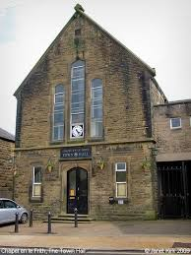
We have increased these by 10% from 1st February, in light of significant rises in utilities costs since the hire rates were last revised in 2022. They are still good value though – please use us for your event!

Annual Parish Meeting – 16th May 2024
Each spring, we hold an Annual Parish Meeting - an open forum for all residents to air any current local issues they wish.
This year’s meeting will be on Thursday 16 May, at the Town Hall at 7pm. Everyone is very welcome, so do please save the date now.
We’re keen to discuss - and get your input to - the Parish Council plans for the coming year.

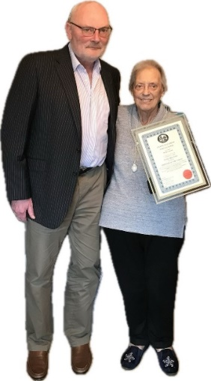
Mary Bellamy, Freewoman of the Parish
The Parish Council was delighted recently to award Mary Bellamy the honour of Freedom of the Parish, to recognise the work she has done for our area for the majority of her life.
Mary was presented with the award by the Council’s chair, Cllr Mike Chantler

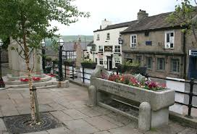
Trees on the Market Place
Following an approach from the Parish Council, High Peak Borough Council has recently confirmed they are responsible for the trees on the war-memorial side of the Market Place and will be pruning them in due course.
The flagstones under these trees are permanently in shade and thus rarely have the opportunity to dry out, so cutting back the tree canopies will be helpful.

May Elections
Elections for Derbyshire’s Police & Crime Commissioner (PCC) happen every 4 years, and next occur here on 2nd May. We shall also be asked to vote on that date for the new role of East Midlands mayor.

Electronic mailing-list for this newsletter
We’re developing an email mailing-list for this newsletter. So, we’d be grateful if as many readers as possible would send a short message to clerk@chapelpc.org giving your consent for your e-address to be added to the mailing-list.
The Parish Council, like all local government bodies, is legally bound by data-protection rules which forbid us to use your data for other than the purpose we have stated, and we certainly won’t. Many thanks for your help!


New Equipment in Chapel Memorial Park
When housebuilders build a new estate, it is often the case that they provide some funds (known as "Section 106" funds) which are ring-fenced for Council spending on improvements to the public realm in the area.
The Parish Council has some S106 funds from Seddon Homes. In March, you will have seen them being spent on works in the Memorial Park to improve the children's play equipment, (to include some accessible equipment for the first time) and to add some adult-gym equipment around the Park.
The apparatus has been selected following the SHIFT Report, which was commissioned by the Parish Council several years ago. The report was written after extensive community engagement including online surveys and community conversations.
Recommendations included:
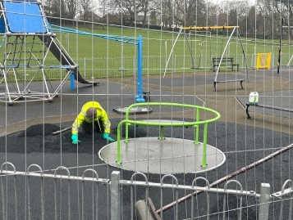
- investment in play fitness equipment for young people
Installation of wheelchair accessible roundabout – March 2024

- providing outdoor gym equipment for adults
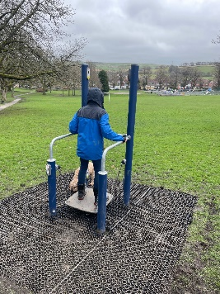
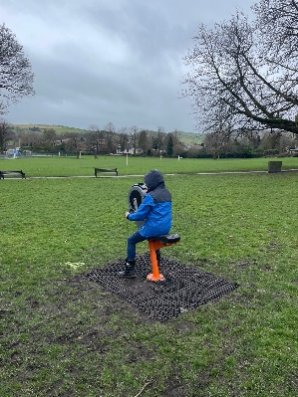
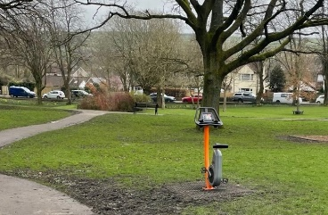
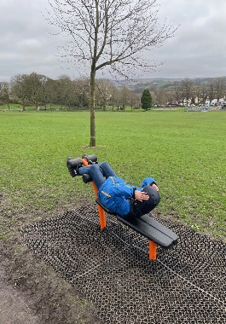
The equipment for all adults is set around on the main path, so they can be accessed easily. There are four pieces of apparatus – a hand bike to increase upper body strength, a station for improving balance and core strength, a static exercise bike and an abs station.
Balance Station
Static exercise bike

Abs Station
Hand bike

Going forward the findings and recommendations of the Shift report will inform future development of the park

Community News
Support for Townend Community Garden

After five years of being the driving force and inspiration for the garden, our dedicated volunteer, Mary Craner, who manages the garden, is sadly standing down due to ill health in September 2024

The Community Garden is looking for a new volunteer manager to support the continued development of this wonderful community resource.

There are two key aspects to the role, so the volunteering role could be split into two parts.

- Supervision of gardening sessions this will include hands-on gardening and supporting adults with learning disabilities. This volunteer would need some gardening experience.

- Administrative and Welcome Group Role – this involves liaising with social prescribers, care coordinators at our local surgery and other organisations to take referrals and monitor people with support needs.


This volunteering opportunity would suit a retired professional gardener or experienced amateur with an interest in also supporting local people with additional needs. We have a volunteer to oversee the garden maintenance they are not able to lead the gardening sessions or take on the support groups

In addition, we are looking for a volunteer to support our Welcome Group, which supports older isolated people. This could be a lovely role for someone not skilled in gardening, as it takes place indoors for much of the year, and activities include craft, seated exercise, mindfulness, singing and visiting speakers.
Mary said “I have been leading the community garden for five years, and it has been incredibly rewarding to see it become a much loved and valued part of Chapel life.”
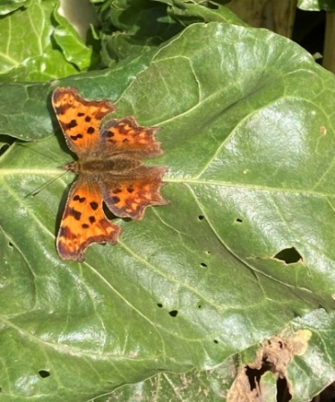
Many local people come and walk around or sit for a while to enjoy the peace. Volunteers have created and continue to maintain a garden bursting with flowers, fruit and vegetables, as well as wild areas to promote biodiversity.

The volunteers support people with mental health issues and those with learning disabilities, older isolated people, for some of whom we provide transport, and young people from our schools. We Awork closely with High Peak CVS and NHS social prescribers to identify people in need.
We have had some lovely community events in the past two years, including the celebration of Queen’s Elisabeth’s platinum anniversary and the coronation of King Charles.

Townend Community Garden 5 Year Anniversary Celebration Open Day May 11th

We are having a grand open day in the garden on May 11th to celebrate our 5-year anniversary.

This would be a good opportunity for anyone interested I becoming the manager of the community garden, on a voluntary basis, to meet the team and find out more about the role.

Dove Holes Car Boot Calendar 2024
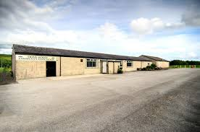
All proceeds go towards supporting our village hall - there is no need to book just turn up on the day.
Refreshments, including hot food are served in the village hall – seating is available
If you are a seller and on your own – don’t worry one of our friendly team will take your order and deliver food and drinks to your stall
Dove Holes Village Hall


Combs Brownies
Combs Brownies Annual Easter Sale with delicious Cream Teas
FREE admission

- Saturday, 23rd March at 2.00 p.m.
- Townend Methodist Church

All are welcome – pick up some spring gifts including
Flowers • Plants • Quiz • Competitions • Bric a Brac • Toys • Games • Books and lots more
Donations for any of the stalls are very welcome

Combs Brownies for girls aged between 7 -10 years, we meet on Wednesdays, from 6.00 p.m. to 8.00 p.m., at Combs Village Hall

If you are interested in finding out about your child joining Combs Brownies, or if you are would like to volunteer.

Please contact: Janet McNicol, Unit Leader, on: 01298 – 812053

Side By Side – Church Shop
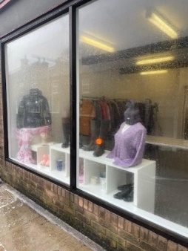
Side by Side Church Shop is on the countdown to opening. We are hoping to be fully open after Easter, so look out for opening times, grab a bargain and support us.
Side by Side is located next to the Church in the old Townend Post Office and opposite The Mustard Seed Coffee Shop.
It is hoped that the new shop provides funds to support the many community activities which take place in the Church, as well as The Mustard Seed and the Community Garden. Once the shop is established, we hope the profits will be shared with local charities that don’t have the benefit of similar premises to support fundraising.
Any donations of goods for sale or offers of help working in the shop would be gratefully received.
Community Information - send your information to us

If you are local community group, charity, individual, or organisation, which supports our community,
We can promote you via the Newsletter, and our social media channels. Please send any information on events, activities, requests for donations, volunteering opportunities, or support with fundraising to:
cllrtdales@chapelpc.org.uk

