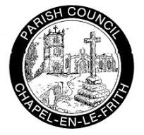
Chapel en le Frith Parish Council Newsletter
December 2023 | Issue 1

A message from the Chair
It gives me great pleasure, as the current Chair of Chapel-en-le Frith Parish Council, to share the first few words of this Parish Council Newsletter.
This is one of our first steps in improving communication with residents. We recognise regular updates from the council have been limited. So, over the coming months, we want to improve this. We have formed a new Communication and Regeneration sub-committee, which will focus on developing new ways to share information. This includes a regular newsletter, made available online and in hard copy and distributed to key places in town.
We want more local people to be involved, as volunteers, in supporting the work of the council, so the coordination of any non-council business matters and drafting the newsletter is being done by a local resident.
The newsletter will evolve overtime, it will include information from the Parish Clerk, which will cover the current activities, business and decisions of the council. It will also include information on local community events and activities to ensure that we keep people as up to date as possible. We welcome feedback on the newsletter and contributions for future issues.
We want to increase engagement with our community. This includes opening up discussions to gain more insight from individuals and local organisations. We need to ensure information is shared through as many channels as possible, so we reach people who are more isolated. This will include improving our presence online via our website and using social media channels.
Members of the Communication and Regeneration committee have been tasked with improving the website and increasing the information shared using social media platforms. We will be sharing their progress with you and responding to feedback on content.
We welcome positive and constructive criticism from residents and recognise its role in stimulating improvements. Parish Councillors come and go but our community always remains the focus. We became Councillors because we care about the places you live in
There will be lots of things to share with you in future newsletters and social media. Some very challenging, others exciting. However, as the first newsletter, of the current council, is published in December, on behalf of the Parish Council. I want to take this opportunity to wish you all a healthy, safe and Happy Christmas
Mike Chantler


Parish Council News
Your Parish Council
The May 2023 election changed the composition of the Council; your parish councillors now are:
Chapel East Ward
- Councillor Jason Adshead
- Councillor Andrew Foreshew-Cain
- Councillor Jim Perkins
Chapel West Ward
- Councillor Alistair Beswick
- Councillor Ian DePee
- Councillor Tim Norton
- Councillor Chris Williams
- Councillor Stewart Young
Combs and Whitehough Ward
- Councillor Mike Chantler
- Councillor Tony Dales
Dove Holes and Martinside Ward
- Councillor Melissa Drabble
The Council usually meets monthly on a Tuesday evening - details are on the meetings calendar on our website https://chapelpc.org. Residents are welcome to attend as observers, and to raise brief points at the start of each meeting.
Would you like to be a parish councillor?
Chapel-en-le-Frith Parish Council invites applications to fill two current councillor vacancies, which we intend to fill by co-option. Applicants are asked to give an outline of why they wish to be considered for co-option to the Council and what they would be looking to achieve in their role as a councillor. Please write to the Clerk of the Council at clerk@chapelpc.org (closing date: 12 noon on 26 January 2024).

Market Place railings
In response to feedback about the untidy appearance of Chapel’s market-place the Council recently introduced a policy of no longer allowing advertising banners to be attached to the railings there.
The Council wants to support local community organisations and charities to promote their events and activities through our social media and newsletters. Please send us information for any event you’d like everyone to know about!
A Parish honour
Parish Councils have long had the legal right to make the award of Honorary Free(wo)man to individuals who have made an especial contribution to local life.
The Parish Council is delighted to have been able recently to make this award (which in Chapel we call Honorary Townsperson) to Mary Bellamy, to recognise the work she has done for our area for the majority of her life. Just some examples are: her over 50 years’ service with the Royal British Legion and her long involvement with the Gardening Club and the Chapel Players. Our hearty congratulations to Mary!
New project for the Memorial Park
At its December meeting, the Parish Council decided to progress a project, which is being funded from a former resident’s generous legacy to us for improvements to the Memorial Park. The project will install 5 x bat-nesting and 5 x bird-nesting boxes. These will help to create a new environment to support local wildlife.
Fibre broadband
The company Fibre Heroes contacted the Parish Council recently. They intend to roll out their fibre broadband network to many homes in the Chapel area from early 2024. We understand that Openreach will also be installing a fibre broadband network in Chapel during 2024.
This will give residents and local businesses a choice. Both the companies mentioned above are network providers, rather than firms who sell broadband access to individuals. Companies who do the latter will each use one of those 2 networks as the host for their product, so you may receive marketing material from several firms.
Electronic mailing-list for this newsletter
We’d like to develop an email mailing-list for this newsletter. So we’d be grateful if as many readers as possible would email: clerk@chapelpc.org giving your consent for your e-address to be added to the mailing-list. The Parish Council, like all local government bodies, is legally bound by data-protection rules which forbid us to use your data for other than the purpose we have stated, and we certainly won’t. Many thanks for your help!

Useful Information: about responsibility for local services.
County councils
These are responsible for services across the whole of a county, like:
- education
- transport
- fire and public safety
- social care
- libraries
- waste management
- household waste recycling centres
- trading standards
- highways/pavements

For more information and to report issues to Derbyshire County Council, contact Call Derbyshire tel: 01629 533190 or by texting 86555.

Borough councils
Cover a smaller area than county councils. They’re usually responsible for services like:
- rubbish collection
- Council Tax collections
- housing
- planning applications
- street cleaning and parking

For more information and to report issues to High Peak Borough Council, contact:
https://www.highpeak.gov.uk/article/2699/Contact-Us
Tel: 0345 129 7777 or 01298 28400
Parish councils
Operate at a level below county and borough councils. They can help on a number of local issues, like providing:
- allotments
- public clocks
- bus shelters
- community centres
- play areas and play equipment
- grants to help local organisations
- consultation on neighbourhood planning

For more information and to report issues to Chapel en le Frith Parish Council, contact:

Tel: 01298 813320
Office Hours:
9.00 a.m. – 12.30 pm. Monday to Friday.
Email: clerk@chapelpc.org
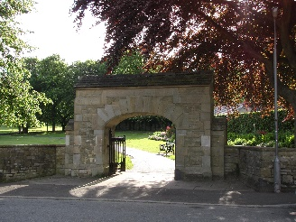
Chapel Memorial Park

Community Information - send your information to us

If you are local community group, charity, individual, or organisation, which supports our community, then please send any information on events, activities, requests for donations, volunteering opportunities, or support with fundraising, then please send information for inclusion in future newsletters, and via our social media channels to:
cllrtdales@chapelpc.org.uk

Town End Methodist Church – The Connection Hub
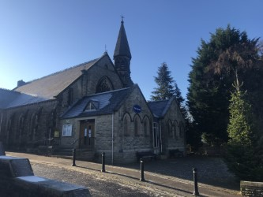
Our vision is to create a connection hub by engaging with the community through worship, nature, leisure, and learning. The project began in April 2023, and has been developed following a very successful engagement event attended by over 200 people during the Coronation weekend. We believe the hub will help us to strengthen links with the community, through existing and new outreach activities.
These include:
- The Community Garden, located between the graveyard and the Primary School,
- The Mustard Seed Café, opposite the Church, which is the base for Chapel Arts and hosts weekly CRESS meeting.
- Foody Fridays, which will relaunch on the first Friday, in February.
To create sustainability we plan to convert the back Sunday School rooms of the church into a large holiday accommodation that is fully accessible for families with mobility needs. The front lounge will be modernised and the sanctuary will also be improved to benefit user groups. This is an ambitious project, but we are excited about the potential it holds to not only keep the church doors open, but to also help us to engage with the community in new and exciting ways.
We were successful in securing a feasibility grant from the Methodist Property Division and grants from the High Peak Methodist Circuit and District. Altogether we have raised £47,000 towards a £168,000 project. We are awaiting results from the community Ownership Fund and the Benefact Trust and are writing a third grant application and submitting our planning and heritage application this month.
Local fundraising support has been amazing too. Deacon’s Bank has selected us as one of three community projects they are supporting this year. We are very grateful for their encouragement and for everyone who is making generous contributions.
The church is delighted that this ambitious project falls during the 150th anniversary year of the current building which will be celebrated on April 9th 2024. This generation, like earlier generations, holds a common vision to serve our community faithfully for years to come.
Side by Side
Side by Side, is a new Church shop which will open in the New Year. It will be located next to the Church, in the old Townend Post Office, opposite The Mustard Seed Coffee Shop and is currently being renovated and fitted out.
The previous church shop, on the Market Place, provided an income for the Church for around 30 years, but was forced to close during Covid. It is hoped that the new shop will again provide funds to support the many community activities which take place in the Church.
Once the shop is established it is hoped that the profits will be shared with local charities, that don’t have the benefit of similar premises to help with their own fundraising.
How you can help
The Church is setting up an online donation page to help fund these projects, but in the meantime please contact Tim Saxby, tmsaxby@tiscali.co.uk. if you are interested in supporting either by volunteering or donating
In addition, Any donations of goods for sale, or offers of help working in the shop would be gratefully received.
Tea and Chat in Chapel – bringing local residents together
Tea and Chat in Chapel was founded five years ago to link friends and neighbours living alone. It began with a tea party and that is pretty much how we have continued – with tea, chat, and lots of good homemade cake. We hold a coffee morning at 89 Market Street (formerly Frank’s) on Tuesday mornings.
We also host afternoon teas – sometimes with themes, such as for the Royal Jubilee. Hold fabulous lunches – including our fabulous Pancake Day celebration. Harvest Suppers and, the highlight of the year, the Christmas dinner. Plus, coach trips – we have just come back from a lovely trip to the Chester Christmas market.
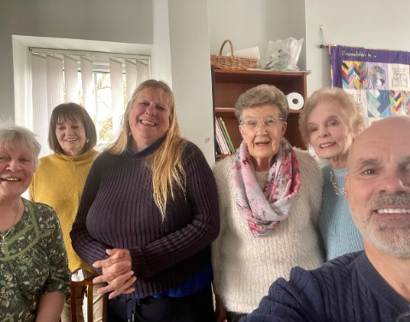
We are run by volunteers, who are also mostly in their 70s. We are always happy to welcome new people into the team to help set up, bake cakes and make people welcome.
And best of all – we don't charge or have a membership fee. We fundraise, obtain donations, and local people are generous. We are particularly grateful to our local Borough and Parish Councillors who have kindly supported us in the past.
Tea and Chat makes a difference. We bring people together, have fun and strengthen friendships and community by reducing isolation.
If you would like to come along give us a call - Fran Cohen (07946 838493) or Andrew Foreshew-Cain (07812 453230).
And, just in case you go shopping at the local Co-op, and are a member, we are one of their partner good causes this year. If you nominate us as your good cause for the year, we get a donation every time you shop there. This costs you nothing but helps us to meet our costs and continue to bring tea and chat to Chapel.

Future issues will include
- Council business update
- Community news
- Spotlight on – this could be a project, community group, or an issue affecting our community
- Get to know your councillors
- Response to feedback
Don’t forget to send us your community news, the next issue should be published between end January to mid-February, until then we wish you……
Merry Christmas and a Happy New Year


